**Excel Homework Conclusions**

1. ***What are three conclusions we can make about Kickstarter campaigns given the provided data?***
   1. Music, theatre and film and video were amongst the most successful groups, achieving success in more than half of their fundraising initiatives. Additionally, although theater did not produce the highest success rate, it produced the most (highest count) successful fundraising projects.

|  |  |
| --- | --- |
| **Category** | **Success Rate** |
| music | 77% |
| theater | 60% |
| film & video | 58% |
| photography | 47% |
| games | 36% |
| technology | 35% |
| publishing | 34% |
| food | 17% |
| journalism | 0% |

* 1. The most successful projects were one with lower fundraising goals. Currency should be converted in the data source prior to completing the graph below. I did not do this.

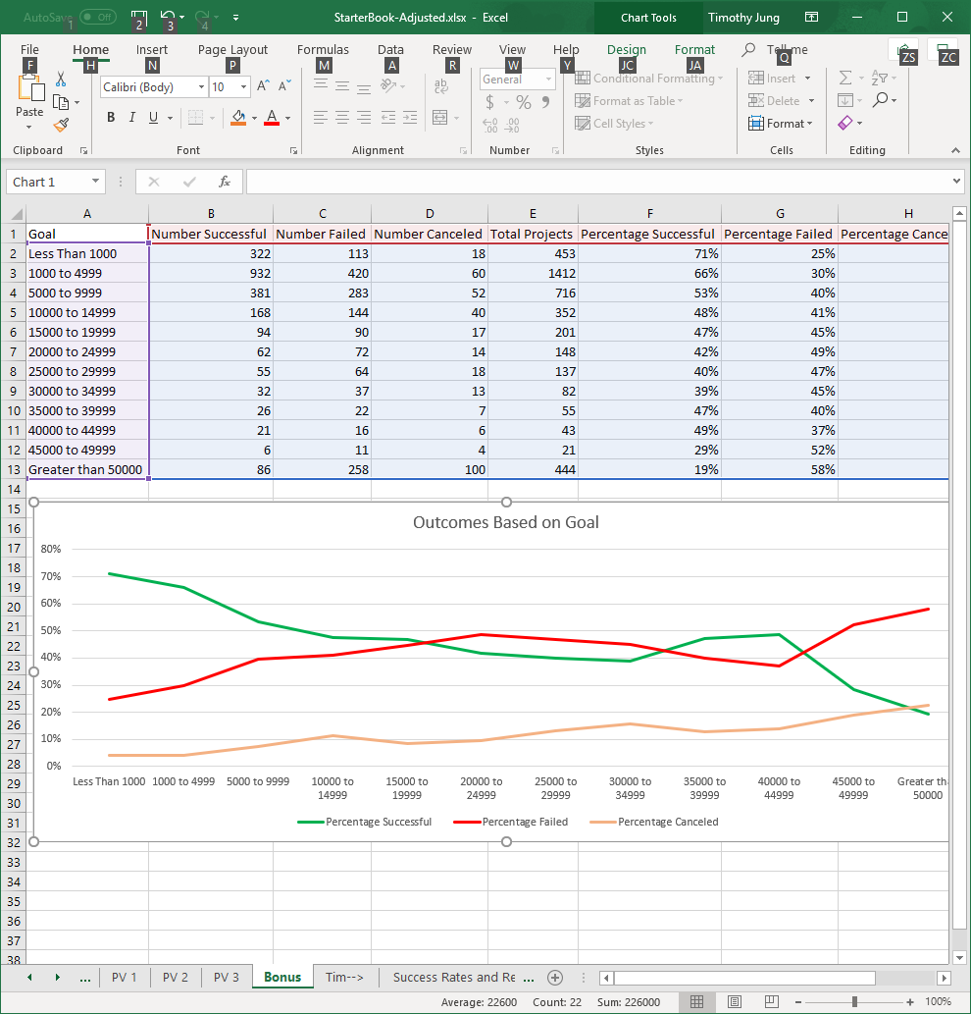

* 1. Goals created in the months from February through June produced the highest success rates.

|  |  |
| --- | --- |
| **Month** | **Success Rate** |
| May | 61% |
| Feb | 60% |
| Apr | 60% |
| Mar | 57% |
| Jun | 55% |
| Nov | 55% |
| Oct | 52% |
| Jul | 50% |
| Jan | 50% |
| Aug | 50% |
| Sep | 49% |
| Dec | 44% |

1. ***What are some of the limitations of this dataset?***
   1. It is difficult to quantify the $ amount of the goals as they are in various currency amounts, and therefore, it can make the bonus figure depict pledged and goal amounts that are not uniform. This should be done to ensure we are accurately quantifying the size and success of various campaigns. Kickstarter may have some bias towards categories with lower data sets, as a small number of successful or failed campaigns show more extreme results.
2. ***What are some other possible tables/graphs that we could create?***
   1. Some other graphs that could have been used to better quantify the result may have been pie charts to depict the campaigns with the highest successes, scatter plots and trend lines to define correlations between high dollar goals and kickstarter support, etc. I also used the tables above help to quantify the total success rate of fundraisers in percentage terms, which is better for apples to apples comparisons, but does not eliminate smaller data sets that are not large enough to be representative. The bar graphs we made can be somewhat misleading, because campaigns that were highly successful (in count) were overshadowed by small categories/sub-categories with a small number of campaigns.

